ST0249   
AI & Machine Learning

Practical 8  
Bots I



What you will learn / do in this lab

1. Explore Bots concepts and applications

TAble of  
Contents

1. Overview 1

Introduction to Chatbots 1

2. Chatbot service setup 2

4. Bot Conversation 9

# 1. Overview

In this practical we will be exploring what are chatbots. We will also be setting up a simple chatbot using Facebook Messenger and DialogFlow.

## Introduction to Chatbots

Chatbot is a computer program designed to simulate conversations with human users, especially over the Internet.

It is a layer on top of, or a gateway to, a service. Sometimes it is powered by machine learning (the chatbot gets smarter the more you interact with it). Or, more commonly, it is driven using intelligent rules (i.e. if the person says this, respond with that).

The services a chatbot can deliver are diverse. Important life-saving health messages, to check the weather forecast or to purchase a new pair of shoes, and anything else in between.

The term chatbot is synonymous with text conversation but is growing quickly through voice communication… “Alexa, what time is it?” (other voice-chatbots are available!)

The chatbot can talk to you through different channels; such as Facebook Messenger, Siri, WeChat, Telegram, SMS, Slack, Skype and many others.

Consumers spend lots of time using messaging applications (more than they spend on social media). Therefore, messaging applications are currently the most popular way companies deliver chatbot experiences to consumers.

# 2. Chatbot service setup

|  |
| --- |
| Objectives:  After completing this lab, you should be able to:   * Create a Chatbot Agent in DialogFlow * Connect the Chatbot Agent to the Facebook Application |

**Exercise 1: Create a DialogFlow Account**

* Navigate to <https://dialogflow.cloud.google.com/>
* Sign in with your Google Account

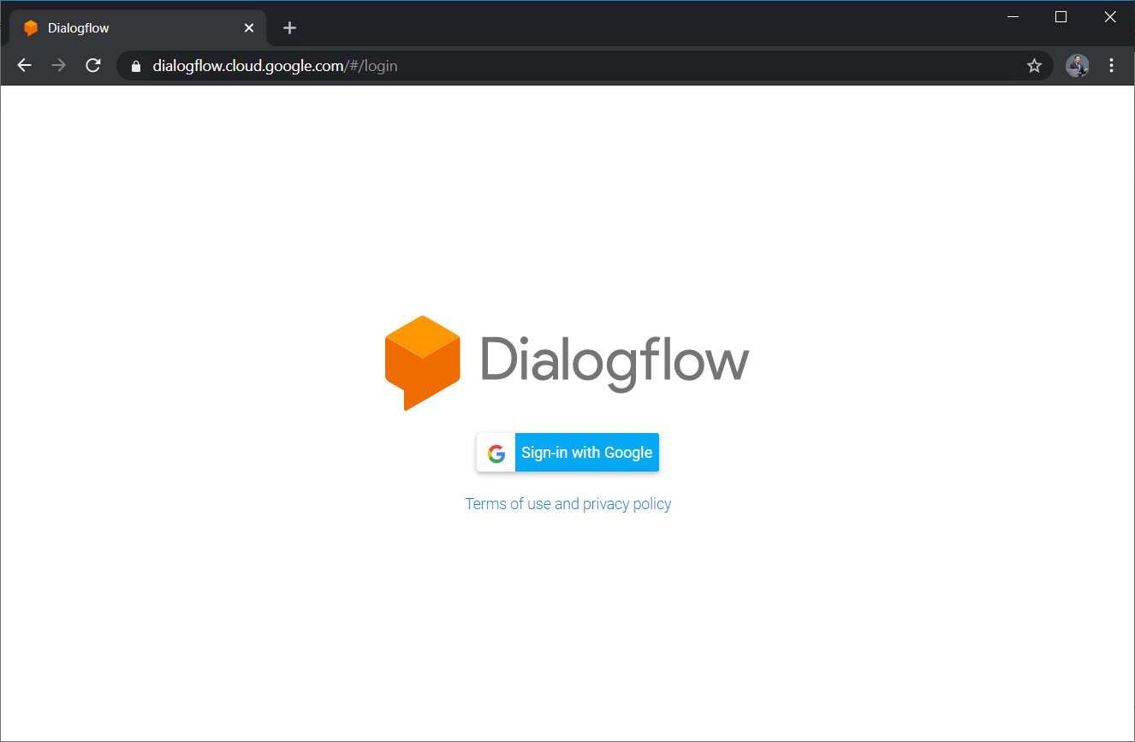

The Console Page should look similar to below

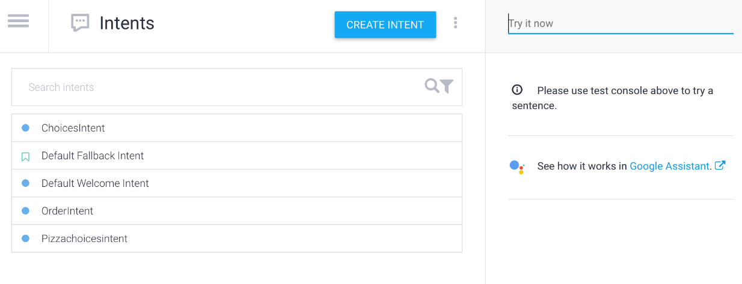

**Exercise 2. Create a New Agent**

Tap on the Create new agent item.

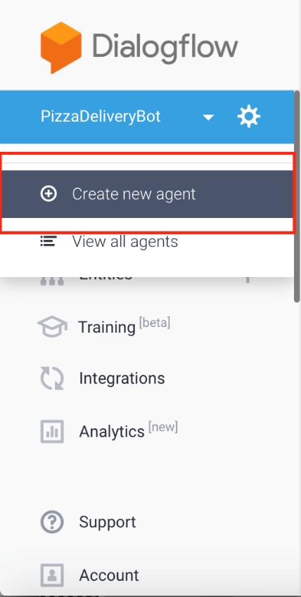

Type the name for your agent.

Click Create

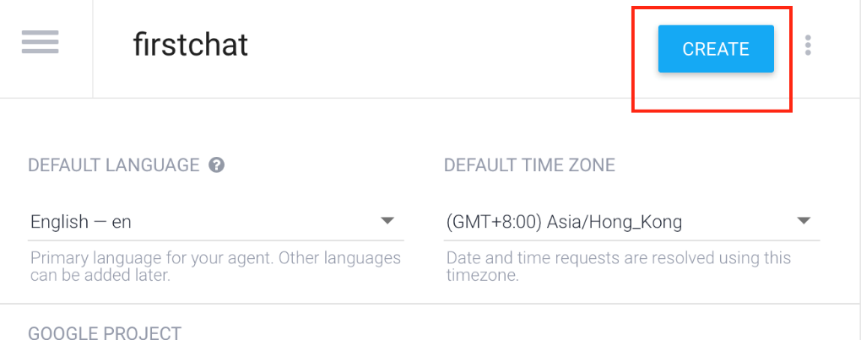

**Exercise 3. Test Agent With Web Demo Chat**

Click Integrations

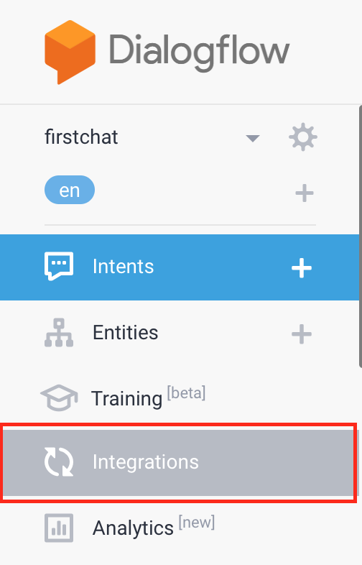

Enable Web Demo

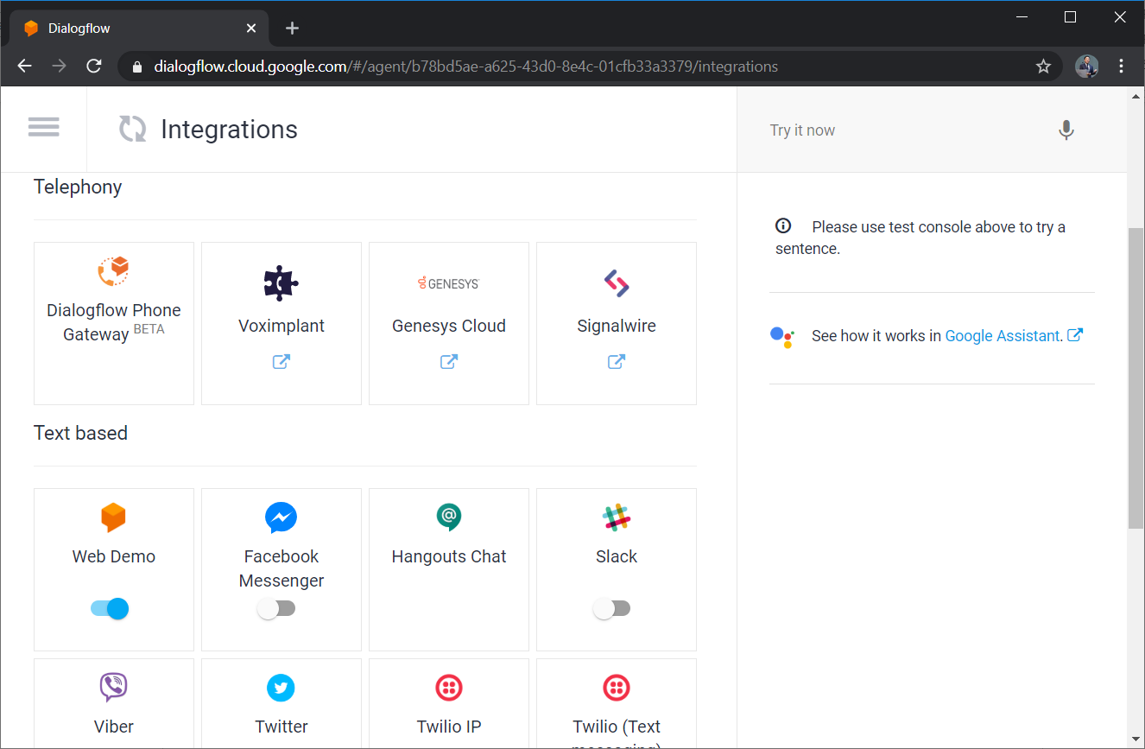

Enable Web Demo Link

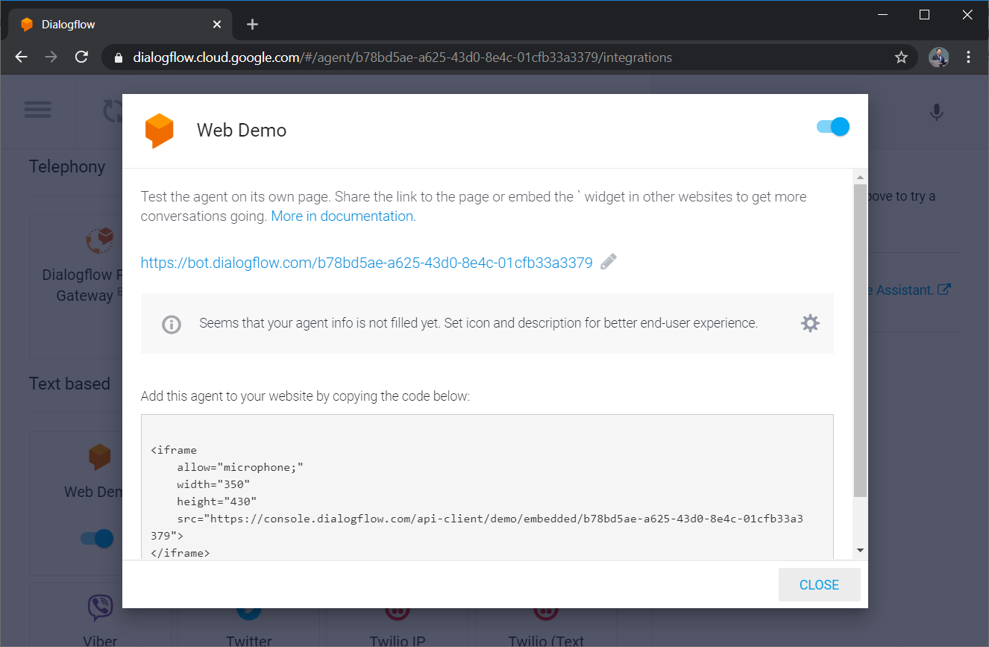

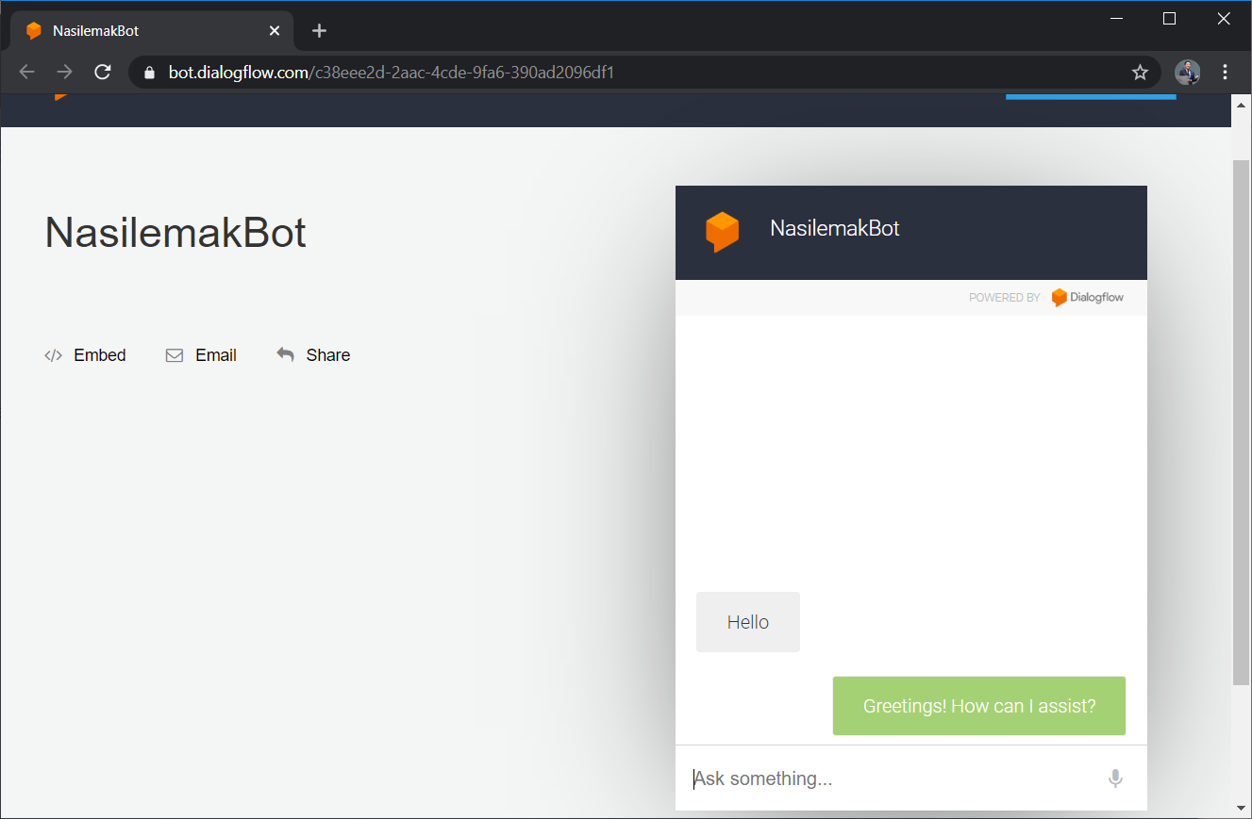

# 3. Bot Conversation

|  |
| --- |
| Objectives:  After completing this lab, you should be able to:   * Send a message and receive a response from the chatbot * Test the chatbot within the Dialogflow website * Use Facebook Messenger to send a message to the chatbot |

**Exercise 1: Create An Intent**

* Navigate to Console (Click the “hamburger” menu)
* Click Create Intent

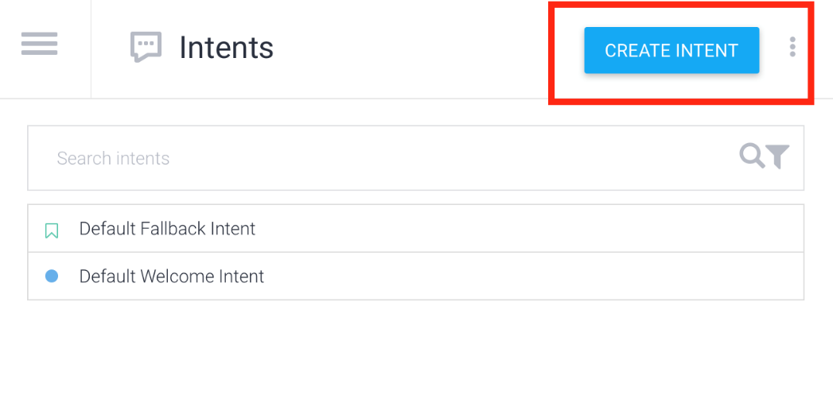

Fill in **Intent Name**, **User Says**, and **Speech Response** as shown below

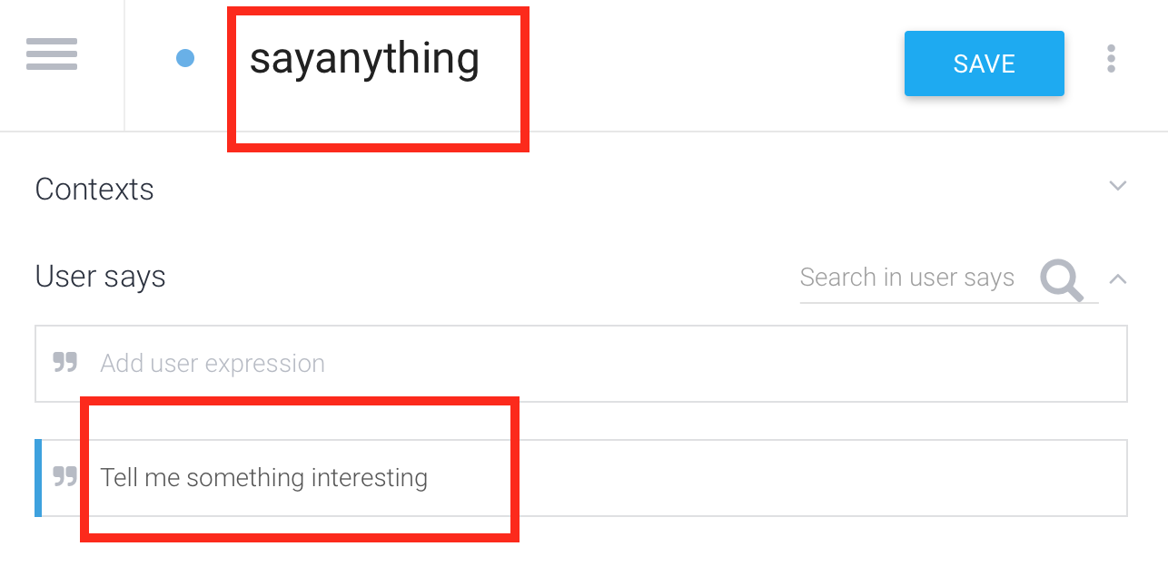

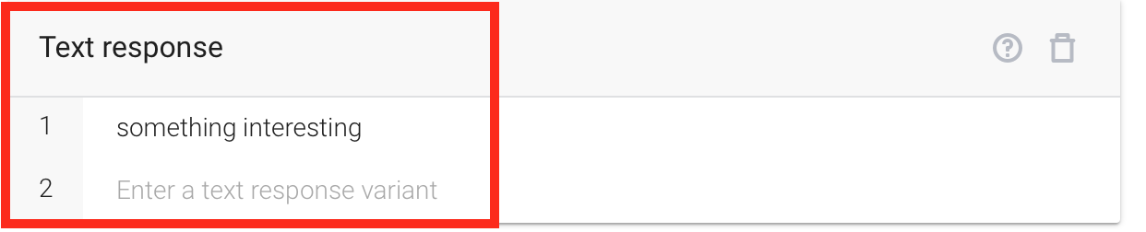

**Exercise 2: Test the Chatbot Within Dialogflow**

* Test out the chatbot in the right hand panel
* Type **“tell me something interesting”** and press enter
* Notice the response is the same as what was specified in the Intent
* Type other similar phrases and observe the results

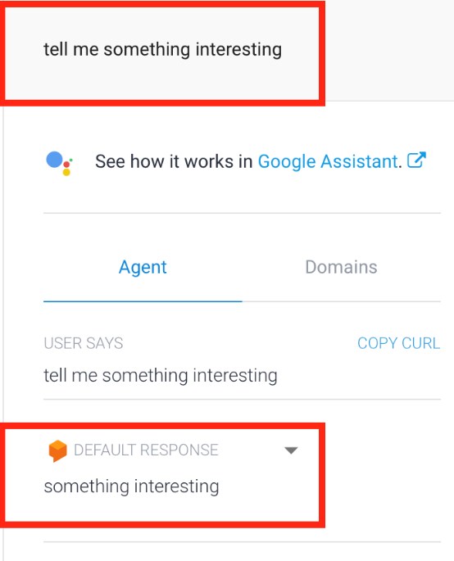

**Exercise 3: Diagnostics**

* In the right hand panel, click **Diagnostic Info**
* The resulting dialog shows JSON code generated by the chatbot.

